A REPORT
on
Hospital Training - I

Submitted in Partial Fulfillment of the requirements For the Degree of
Bachelor of Pharmacy
By

RAVI KUMAR B.Pharm. IIIYear, V Semester
Roll No.: 2110180500064

Ambekeshwar Institute of Pharmaceutical Sciences (Lucknow)



Under the Supervision of
SUPERVISOR
Prof (Dr.) Savita Upadhyay Director (Pharmacy)
AIPS, Lucknow

CO-SUPERVISOR
Dr. Ila Dixit
Associate Professor AIPS, Lucknow

to the

Faculty of Pharmacy
Dr. A.P.J. Abdul Kalam Technical University, Lucknow 2023-2024



CERTIFICATE OF COMPILATION

This is to certify that this project report entitled “Hospital Training - I” submitted to Ambekeshwar Institute of Pharmaceutical Sciences, Lucknow, is a bonafide record of work done by Ravi Kumar (Roll No.:2110180500064) during the period of his/her study in Bachelor of Pharmacy in the academic year 2023-2024 in the fifth semester of third Year.

SUPERVISOR
Prof (Dr.) Savita Upadhyay Director (Pharmacy)
AIPS, Lucknow
CO-SUPERVISOR
Dr. Ila Dixit
Associate Professor
AIPS, Lucknow

EXTERNAL EXAMINER

DATE: ……………………

COPYRIGHT

Declaration by the Candidate

I hereby declare that the Ambekeshwar Institute of Pharmaceutical Sciences, Lucknow shall have the rights to preserve, use and disseminate the report in print or electronic format for academic/ research purpose.

Place: Lucknow Ravi Kumar
Date: Roll No.:2110180500064

DECLARATION BY THE CANDIDATE

This is to certify that the work presented in the report entitled “Hospital Training - I” has been carried out by me for the partial fulfillment of degree of ‘Bachelor of Pharmacy’ under the supervision of Prof (Dr.) Savita Upadhyay and Co-supervision of Dr. Ila Dixit of Ambekeshwar Institute of Pharmaceutical Sciences, Lucknow.
The report embodies results of the original work and studies carried out by me and the contents of the report have not formed the basis for the award of any degree/ diploma by any other University or Institution.
I also confirm that all the material which I have borrowed from other sources and incorporated in this report is duly acknowledged.

Place: Lucknow Ravi Kumar

Date: Roll No.: 2110180500064

CERTIFICATE BY THE CO-SUPERVISOR

This is to certify that the work presented in the report entitled “Hospital Training - I” submitted by Ravi Kumar (Roll No.:2110180500064) for the degree of ‘Bachelor of Pharmacy’ has been carried out in the Ambekeshwar Institute of Pharmaceutical Sciences, Lucknow under my guidance.

Place: Lucknow

Date:
Dr. Ila Dixit
Associate Professor AIPS, Lucknow

CERTIFICATE BY THE SUPERVISOR

This is to certify that the work presented in the report entitled “Hospital Training - I” submitted by Ravi kumar (Roll No.:2110180500064) for the degree of ‘Bachelor of Pharmacy’ has been carried out in the Ambekeshwar Institute of Pharmaceutical Sciences, Lucknow under the co-supervision of Dr. Ila Dixit, Associate Professor, Ambekeshwar Institute of Pharmaceutical Sciences, Lucknow.

Place: Lucknow

Date:
Prof (Dr.) Savita Upadhyay
Director (Pharmacy) AIPS, Lucknow

I am very glad to be attached with RAM SAGAR MISHRA 100 BEDDED COMBINED HOSPITAL, BKT LUCKNOW and get a great chance for learning some hospital work.
I feel very obliged to get an opportunity to be a part of this hospital.
I am using this opportunity to express my deepest gratitude and special thanks to Ambekeshwar Institute of Pharmaceutical Sciences, Lucknow who gave us an opportunity to get some knowledge about hospital and its functioning.
It is my sincere and deepest gratitude to MR. RAJESH JHA for their careful and precious guidance which really helps me to get some extreme knowledge about hospital management. This knowledge is very valuable for me. I also thanks to the doctors, and staff who always support and help me to learn new methodologies.
I also thanks to my parents, family and friends who always supported me to get something new in my life. I always grateful for their immense support and guidance for completing the training procedure
The guidance and support received from all the members who contributed to this study was vital for the completion of this study. We are grateful to all of them for their constant support and guidance either directly or indirectly towards completion of our training.

Place: Lucknow

Date:
Ravi kumar

Table no.1: Name of drugs 14

List of Figures
Figure no.1-Hospital 1
Figure no.2-Ambulance 4
Figure no.3-First aid 5
Figure no.4-CPR 7
Figure no.5-Emergency 10
Figure no.6-Labour room 12
Figure no.7-Dispensary 14

List of Abbreviations

Abbreviation | Name
CPR | Cardiopulmonary resuscitation
OPD | Outpatient department
ED | Emergency department
TIA | Transient ischemic attack
LDR | Labor delivery room
LDRP | Labor delivery recovery postpartum
CSF | Cerebrospinal fluid
DNA | Deoxyribonucleic acid
CBC | Complete blood count

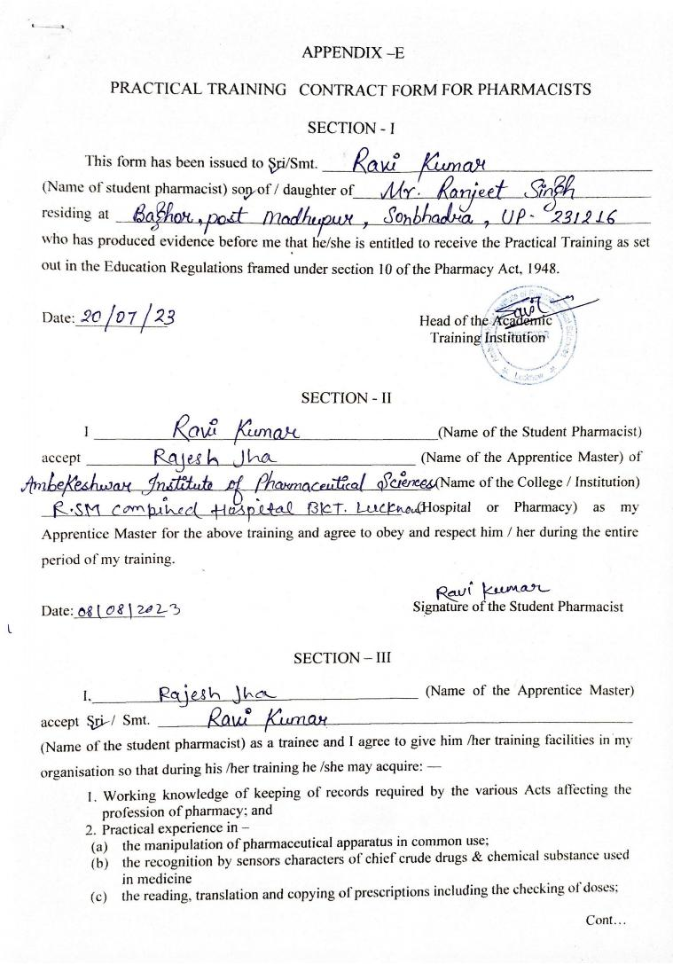

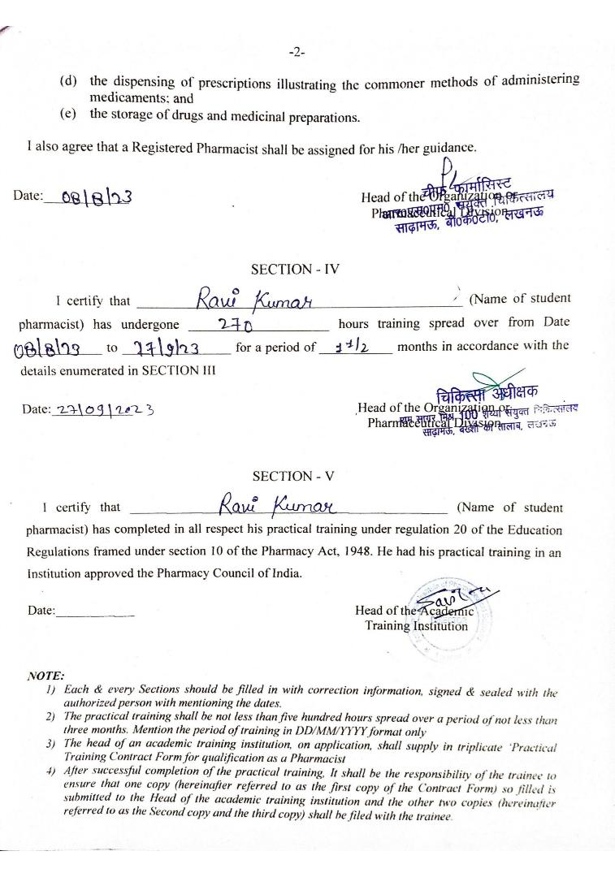

CONTENTS

S. No | Particulars | Page No.
1. | Certificate of Compilation | ii
2. | Copyright | iii
3. | Declaration by the Candidate | iv
4. | Certificate by the Co-Supervisor | v
5. | Certificate by the Supervisor | vi
6. | Acknowledgement | vii
7. | List of Tables | viii
8. | List of Figures | ix
9. | List of Abbreviation | x
10. | Practical Training Contract Form for Pharmacists | xi-xii
11. | Introduction | 1
12. | Hospital Profile | 2
13. | Training Imparted | 3-17
14. | Observation | 18
15. | Result and Discussion | 19
16. | Conclusion | 20
17. | Bibliography | 21

INTRODUCTION

Hospital, an institution that is built, staffed, and equipped for the diagnosis of disease; for the treatment, both medical and surgical, of the sick and the injured; and for their housing during this process. The modern hospital also often serves as a centre for investigation and for teaching.
To better serve the wide-ranging needs of the community, the modern hospital has often developed outpatient facilities, as well as emergency, psychiatric, and rehabilitation services. In addition, “bed less hospitals” provide strictly ambulatory (outpatient) care and day surgery. Patients arrive at the facility for short appointments. They may also stay for treatment in surgical or medical units for part of a day or for a full day, after which they are discharged for follow-up by a primary care health provider.
Hospitals have long existed in most countries. Developing countries, which contain a large proportion of the world’s population, generally do not have enough hospitals, equipment, and trained staff to handle the volume of persons who need care. Thus, people in these countries do not always receive the benefits of modern medicine, public health measures, or hospital care, and they generally have lower life expectancies.
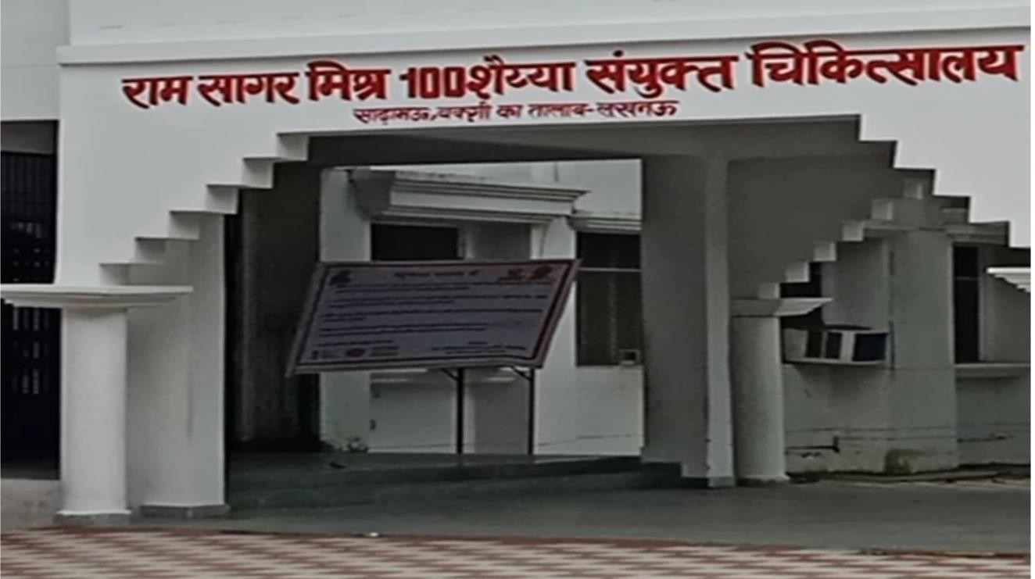

Figure no.1- HOSPITAL

HOSPITAL PROFILE
According to the hospital definition, a district hospital is usually the region's primary healthcare facility, with a large number of intensive-care beds and extra beds for patients who need long-term care. Trauma centers, children's hospitals, rehabilitation hospitals, hospitals, and seniors' (geriatric) hospitals for coping with particular medical conditions such as psychiatric care are also examples of specialized hospitals and several other disease categories. When opposed to general hospitals, specialized hospitals can help save money on health care. Based on the source of revenue, hospitals are categorized as general, specialized, or government.
A teaching hospital integrates patient care with medical students as well as nurse education. A clinic is a care facility that is smaller than that of a hospital. A hospital's departments (such as surgery and urgent care) and specialty units (such as cardiology) are diverse. Outpatient departments and chronic care centers are available at certain hospitals. Pathology, pharmacy, and radiology are examples of common support units.

Different Departments in Hospital (Various Departments in Hospital)
Below given are the details of different departments in the hospital:-
- Outpatient department (OPD), Surgical department, Inpatient service (IP), Nursing department, Physical medicine, Paramedical department, and Rehabilitation department, Dietary department, Pharmacy department, Operation theater complex (OT), Radiology department (X-ray), and Non-professional services are some of the departments located in hospitals.
- A nursing department, led by a director of nursing or a chief nursing officer, might exist in a hospital. Such a department has the responsibility of overseeing the hospital's clinical nursing practice, research, and regulation.
- Numerous units also have nursing as well as a medical director who also acts as a supervisor for their subject areas. A medical director, for instance, is in charge of doctors and medical treatment in an intensive care nursery, whereas the nursing manager is in charge of both nurses and nursing healthcare.
- Health records, technical support, disclosure of information, facilities management, clinical engineering, dining services, and plant operations, are examples of support units.

HOSPITAL SERVICES
Below mentioned are some of the hospital services:-
  - Emergency room services
  - Short-term hospitalization
  - X-ray/radiology services
  - General and specialty surgical services
  - Blood services
  - Laboratory services

Facilities
  - OPD Services for Indoor Patients
  - Test Facilities
  - X- Ray Facilities
  - Operation Facilities
  - Ambulance facility
  - Abortion
  - Delivery
  - Immunization
  - Dental health
  - Immunization of TB, Polio, Diphtheria, Tetanus, Whooping Cough and Measles in infants
  - Eye Care
  - Registration of death and birth
  - Free Oral Contraceptive pills, Condom Pieces.
Allied health, including audiology, dietics, exercise physiology, physiotherapy occupational therapy and speech therapy.

Aims of health services
Health services aim to improve the health and wellbeing of residents by:
  - Encouraging people to actively participate in their own health care.
  - Working together with other primary health care providers such as general practitioners(GPs) to provide coordinated care.
  - Liaising with other health agencies and service providers to fill service gaps.
  - Encouraging individuals and community groups to actively participate in the center’s

activities, including service planning, fundraising and volunteer work.
  - Promoting prevention of lifestyle-related diseases and conditions.
  - Developing health care programs and activities to improve social and physical environments in the community.

AMBULANCE SERVICE
108 is predominantly an emergency response system, primarily designed to attend to patients of critical care, trauma and accident victims etc.
102 services essentially consist of basic patient’s transport aimed to cater the needs ofpregnant women and children though other categories are also taking benefits and are not excluded. JSSK entitlements e.g., free transfer from home to facility, inter facility transfer in case of referral and drop back for mother and children are the key focus of 102 services.
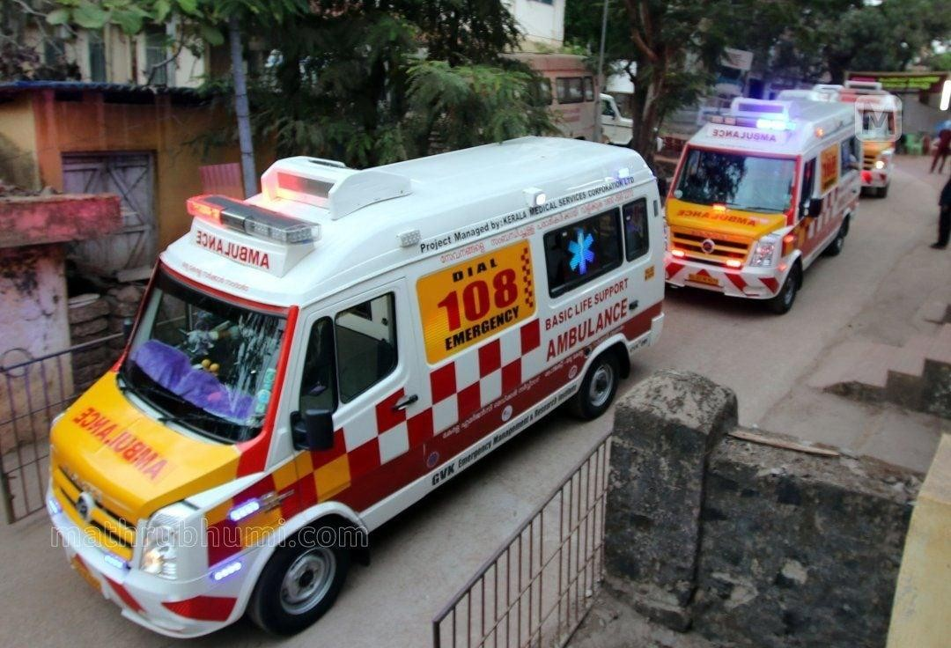
Figure no.2- AMBULANCE

FIRST AID TREATMENT
When you provide basic medical care to someone experiencing a sudden injury or illness, it’s known as first aid.
In some cases, first aid consists of the initial support provided to someone in the middle of a medical emergency. This support might help them survive until professional help arrives.
In other cases, first aid consists of the care provided to someone with a minor injury. For example, first aid is often all that’s needed to treat minor burns, cuts, and insect stings.

Aims of first aid
The primary goal of first aid is to prevent death or serious injury from worsening. The key aims of first aid are-
  - Preserving life
  - Preventing injury or illness from getting worse
  - Relieving pain
  - Aiding recovery
  - Protecting the unconscious
The primary aim is to of course save lives. These main aims are so important in doing that, if they are properly implemented.
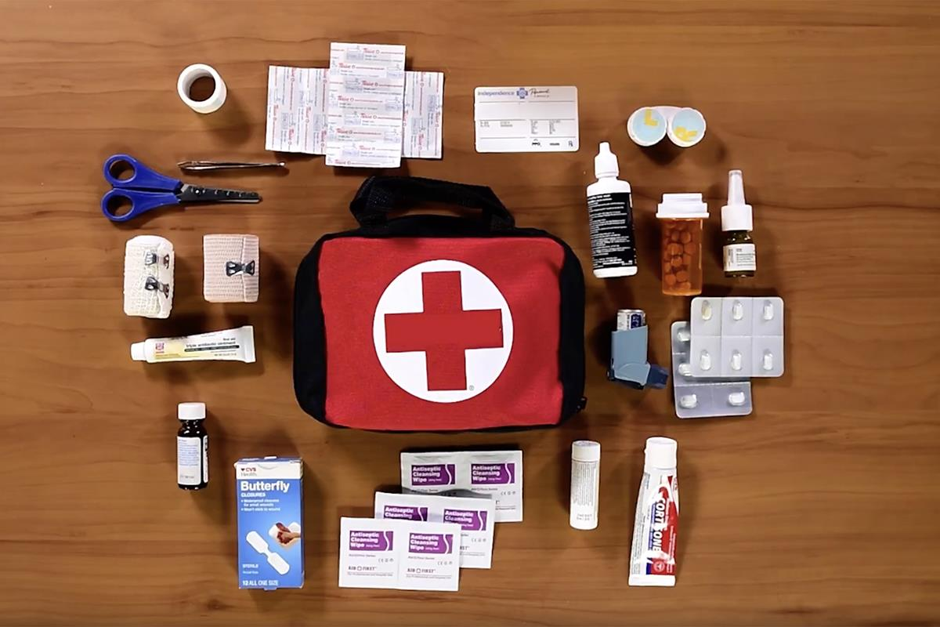
Figure no.3–FIRST AID

3 steps for emergency situations
If you encounter an emergency situation, follow basic steps:

Check the scene for danger
Look for anything that might be dangerous, like signs of fire, falling debris, or violent people. If your safety is at risk, remove yourself from the area and call for help. If the scene is safe, assess the condition of the sick or injured person. Don’t move them unless you must do so to protect them from danger.

Call for medical help, if needed
If you suspect the sick or injured person needs emergency medical care, tell a nearby person to call 108 or the local number for emergency medical services. If you’re alone, make the call .

Provide care
If you can do so safely, remain with the sick or injured person until professional help arrives. Cover them with a warm blanket, comfort them, and try to keep them calm. If you have basic first aid skills, try to treat any potentially life-threatening injuries they have. Remove yourself from danger if at any point in the situation you think your safety might be at risk.

First aid bandage
In many cases, you can use an adhesive bandage to cover minor cuts, scrapes, or burns. To cover and protect larger wounds, you might need to apply a clean gauze pad or roller bandage.
To apply a roller bandage to a wound, follow these steps:
  - Hold the injured area steady.
  - Gently but firmly wrap the bandage around the injured limb or body part, covering the wound.
  - Fasten the bandage with sticky tape or safety pins.
  - The bandage should be wrapped firmly enough to stay put, but not so tightly that it cuts off blood flow.

First aid for burns
If you suspect that someone has a third-degree burn, call helpline no. Seek professional medical carefor any burns that:
  - Cover a large area of skin
  - Area located on the person’s face, groin, buttocks, hands, or feet
  - Have been caused by contact with chemicals or electricity

First aid CPR
If you see someone collapse or find someone unconscious. If the area around the unconscious person seems safe, approach them and begin CPR.
Even if you don’t have formal training, you can use hands-only CPR to help keep someone alive until professional help arrives.
Here’s how to treat an adult with hands-only CPR:
  - Place both hands on the center of their chest, with one hand on top of the other.
  - Press straight down to compress their chest repeatedly, at a rate of about 100 to 120

compressions per minute.
  - Compressing the chest to the beat of “Staying Alive” by the Bee Gees or “Crazy inLove” by Beyoncé can help you count at the correct rate.
  - Continue performing chest compressions until professional help arrives.
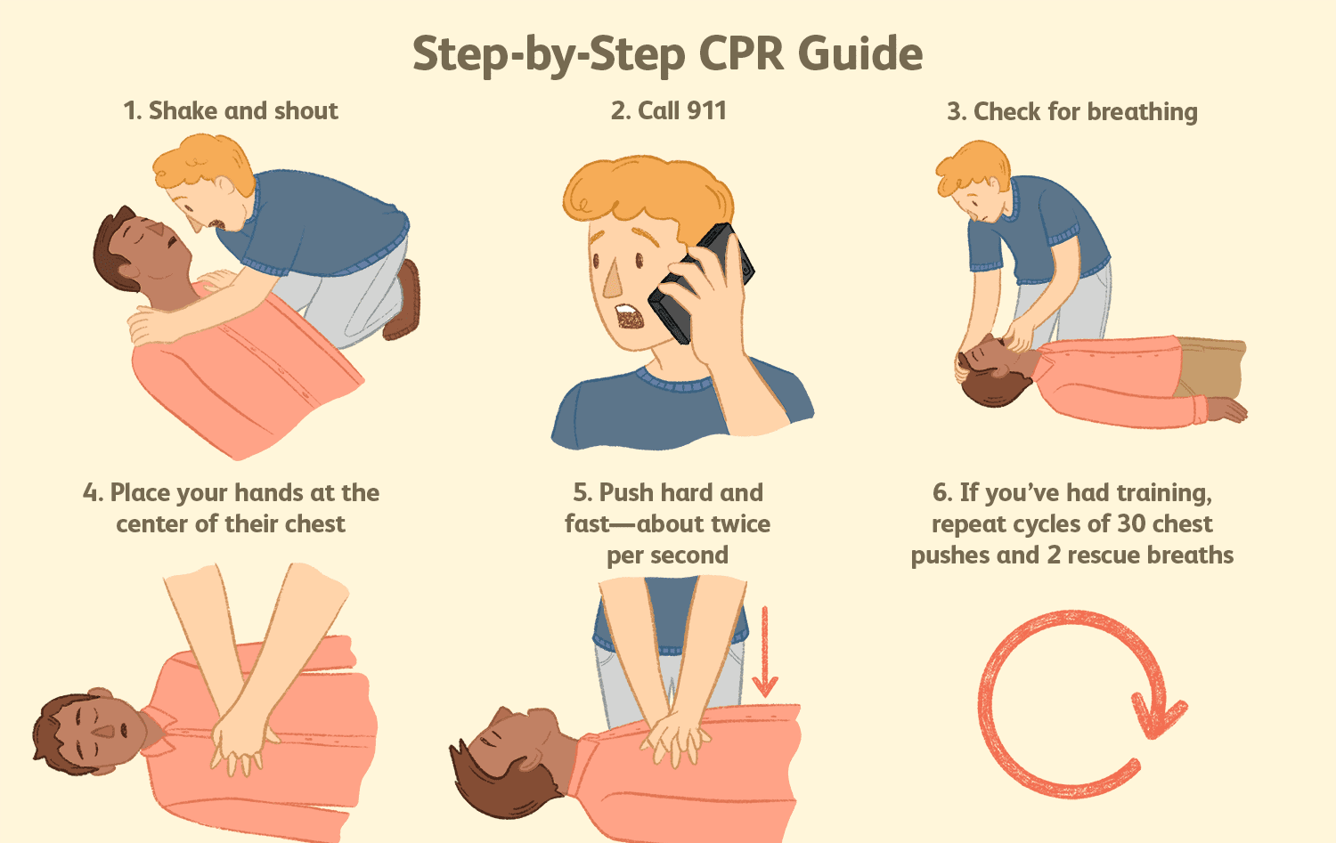

Figure no.4-CPR

OUTPATIENT

An OPD is a hospital department designed to be a first contact point between the patient and the hospital staff. A patient who goes first time to the hospital, he directly goes to OPD and then the OPD decides to which department a patient should go.
Generally, an OPD is constructed on the ground floor of any hospital and divided into several parts like neurology departments, orthopedics department, gynecology department and general medicine department etc. Here the patient completes all the formalities and then go the respective department.
It is the section of any hospital where the patients that require medical attention are treated. Here, the doctor examines the patient; conducts necessary tests, and prescribes medication and

treatment on the basis of the health condition of the patient. Hospitals have OPD wards for providing attention to the patients and conducting medical treatments.
An outpatient is the patient who is not hospitalized for 24 hours or more but visit the hospital or clinic for treatment or diagnosis.

Services Provided by the OPD
OPDs provide all general services and facilities which are necessary for any hospital. OPDs act as the first step for consulting the doctor and getting the tests done to proceed with treatment.

These services are classified as-

Prevention and wellness
OPDs provide guidance to the patients for overall wellness and prevention of health issues. Doctors guide patients to maintain a healthy weight, improve sleep, balance sugar levels etc.

Diagnosis
OPD is the first place where the patient and doctor meet and discuss the patient’s health condition. After discussing the issue, the doctor suggests the necessary tests for the patient. The lab tests and MRI scans are conducted in the OPD.

Treatment
Treatment and minor surgeries can be done in the OPD. Modern OPD has all the necessary equipment to treat a patient. Surgeries such as cuts, wounds etc, can be easily handled in the modern OPD.

Features of OPD
  - It acts as the first point where the patient and the healthcare system interact with each other.
  - It is the most important step in health promotion and vital in the prevention of diseases.
  - The screening is done to find the illness and see whether the patient needs admission to the hospital.
  - All patients can easily access the medical practitioners and get the treatment done.
  - It facilitates vaccination, common illness, or minor surgeries

Types of Outpatient Department
There are different types of OPD like ENT (ear, nose, and throat), pediatric, skin,and eyes. These types are based on the function and facility they offer. Several other OPDs are also there, which contribute to the easy working of the healthcaresystem. Such types are OPDs are-

Primary Care Clinic
Primary care clinics are facilities where patients consult the physicians. These physicians conduct tests and direct the patient to specialists when the need arises.

Community clinic
The community health clinic is for the people who cannot access healthcare. These allow people with low incomes, no health insurance, workers.

Urgent Care Center
The urgent care center is a clinic that serves the purpose of an emergency ward. It is for those treatments which require urgent attention but are not life threatening.

Specialized Outpatient Clinic
It is for the patients suffering from a specific illness under the specialization like cardiology, nephrology, wound care, pain management, chemotherapy treatment, and radiation treatment at specific center.

EMERGENCY DEPARTMENT
The ED plays an important role in providing patients with prompt and effective clinical care. It is the healthcare entry point responsible for receiving, sorting, urgency and complexity. Conditions of patients requiring an emergency care vary from major trauma and stroke to intoxication and mental disorders. Therefore, emergency department is considered to be an extremely Complex system.
Improper facility design can lead to numerous problems. In the ED in particular, crowding is a prominent problem. Crowding is associated with increased patient mortality, poor quality of care, extended waiting times, increased rates of patients left without being seen, and extended length to stay.

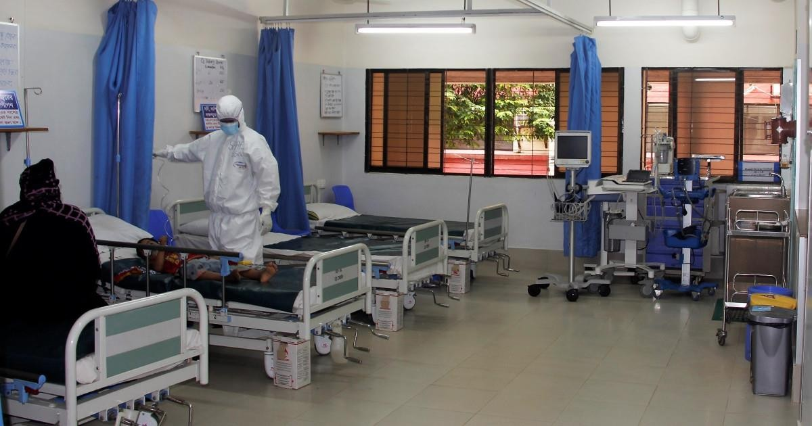

Medical Emergencies
Figure no.5-EMERGENCY

Bleeding
Cuts and wounds cause bleeding, but severe injury can also cause internal bleeding. Not all incidents of bleeding need emergency medical treatment, often they can be treated by first aid at home.
If there is a large amount of blood loss, the injured person may begin to feel unwell, appear pale, feel dizzy and, in some cases, lose consciousness. If this happens, urgent medical attention required.

Breathing Difficulties
There can be a number of reasons why someone may have difficulties in breathing.
e.g., asthma attacks, allergic reaction (anaphylaxis), and coughs or colds.
Breathlessness can occur during exercise or physical activity, but if the breathlessness comes on suddenly or unexpectedly, then this can be a warning sign.
If someone is having breathing difficulties, they may experience some or all of the following symptoms:
- Pain when taking deep breaths or feeling like their chest is tight.
- Feeling short of breath or unable to catch their breath.

- Breathing shallower or faster than normal.
- Noisy breathing including a wheeze gasps or whistles.
If someone is experiencing breathing difficulties, they may feel panicked, which can affect their breathing. It’s important to try and keep the situation calm if possible.

Someone Collapses
If someone has collapsed, they are likely to need medical attention. This is because their levels of consciousness or breathing could be affected.

Fit and/or epileptic seizure
Fits and seizures can occur in people who have a diagnosis of epilepsy, but can also occur in people who don’t have such a diagnosis.
A fit or seizure can involve the involuntary and uncontrollable jerking, twitching or shaking of part or all of the body.

Severe pain
Everyone can experience pain in different ways, depending on their pain threshold. We all experience aches and pains from time to time.
Pain can occur suddenly or increase over a period of time. Pain can be caused due to illness or injury. Severe pain tends to be more intense and, in some cases, will stop people from being able to carry out normal daily activities.

Heart Attack
It is a serious life-threatening medical emergency where the supply of blood to the heart is suddenly blocked. Heart attacks are more common in adults, but can occur in children and teenagers. If someone is having a heart attack, they may experience some of the following symptoms:
- Chest pain, both arms can be affected as well the neck, jaw, back and stomach.
- Shortness of breath and sweating

Stroke
A stroke is a serious life-threatening medical condition which occurs due to the blood supply to part of the brain being cut off.
This can happen because of a blood clot or a bleed on the brain. There are two main causes of

stroke: a blocked artery (ischemic stroke) or leaking or bursting of a blood vessel (hemorrhagic stroke). Some people may have only a temporary disruption of blood flow to the brain, known as a TIA, that doesn't cause lasting symptoms.

Ischemic Stroke
This is the most common type of stroke. It happens when the brain's blood vessels become narrowed or blocked, causing severely reduced blood flow (ischemia). Blocked or narrowed blood vessels are caused by fatty deposits that build up in blood vessels or by blood clots or other debris that travel through your bloodstream and lodge in the blood vessels in your brain.

LABOR DELIVERY ROOM
It is the most versatile room in the hospital. The room is used for labor, delivery, and the initial phase of recovery. These state-of-the-art rooms are fully equipped and completely sterilized to ensure comfortable and safe birthing. They are also equipped to handle minor emergencies, and procedures including forceps deliveries, and vacuum deliveries.
The LDR is designed for nearly all births. It can handle a birth for women choosing to go unmediated or those who wish to have an epidural. The vast majority of these rooms can also handle minor emergencies and procedures including forceps and vacuum deliveries. You would only need to leave this room if you needed to go to the operating room for a cesareanor the high potential of a cesarean (such as in the cases of twin births or a vaginal breech birth attempt).
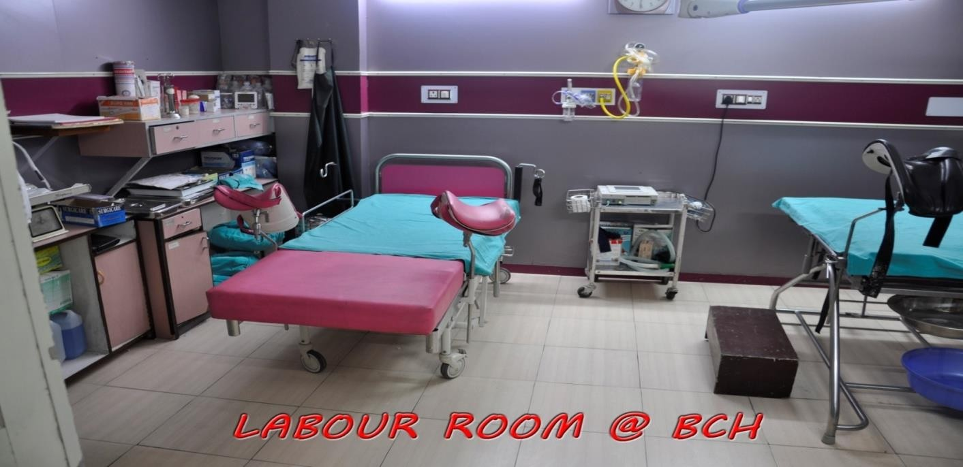
Figure no.6-LABOUR ROOM

Labor delivery recovery postpartum (LDRP) rooms
Some facilities also offer Labor, Delivery, Recovery, and Postpartum room. In the LDRP, you will give birth here and your baby will stay with you until you are ready to go home. Many of these facilities use the nursery only for babies who are ill, rather than for well newborn care.
As with the LDR, the LDRP is equipped to handle only vaginal births. You can have an epidural or other pain medication in this room if they are available at your place of birth and if you are in a hospital and require it, you may also have a forceps or vacuum delivery in the vast majority of LDRP rooms. If you require a c-section at the hospital, you will generally not recover in the LDR or the LDRP, even if you labored in one.
Some Features of Labor and Delivery Room

  - Bed- Labor and delivery beds breaks down in the middle to become birthing beds complete with stirrups, handle and even a birthing bar (to hold on to as you push) some models. Post-delivery, they are whisked back together with a nary a sign of the incredible transformation that just happened.

  - Medical Equipment- There is a surprising amount of medical equipment tucked away neatly and discreetly in labor and delivery room in case of an emergency. There may be suction and oxygen receptacles hidden behind those pretty pictures on the walls

  - Fetal Monitor - Along with your bed, your IV pole, and your blood pressure equipment, most labor and delivery rooms house a bedside fetal monitor that attaches to the mother’s belly to monitor contractions and the baby’ heart rate.

  - Partner chair- If your partner will be staying overnight with you, expect to find a chair that unfolds into a bed for a semi - comfortable slumber.

DRUG DISTRIBUTION ROOM
Drug distribution room is a department within a hospital that prepares, compounds, stocks, dispenses inpatient medication. Drug distribution usually stocks a larger range of medications, including more specialized and investigational medications than would be feasible in the community setting. It can also dispense over the counter and prescription medications to outpatients. It may provide a huge quantity of medications per day which is allocated to the

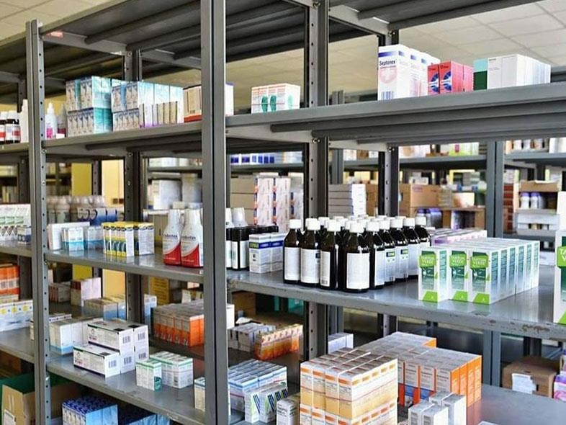
wards and to intensive care units according to the patient’s medication schedule. Larger hospital may use automated transport systems to aid in the efficient distributions of medications. In drug distribution room many varieties of drugs are present which are helpful in the treatment of poor people.
Figure no.7-DISPENSERY

EXAMPLES OF DRUGS

Table No.1–Name of drugs

S.NO | NAME OF DRUGS | MFD | EXP
1. | Cholecalciferol tablets | APR 2021 | SEP 2022
2 | Ciprofloxacin Hydrochloride Tablets | JUNE 2021 | MAY 2023
3. | Montelukast tablets | JAN 2021 | DEC 2022
4. | Ibuprofen Tablets | JUNE 2021 | MAY 2024

5. | Tinidazole Tablet 300 mg | JULY 2021 | DEC 2022
6. | Fluconazole Tablets 150 mg | DEC 2020 | NOV 2022
7. | Bisacodyl Gastro-Resistant Tablets 5 mg | Dec2020 | NOV 2022
8. | Folic Acid Tablets 5 mg | SEP 2020 | AUG 2022
9. | Trihexyphenidyl Hydrochloride Tablet 2 mg | JAN 2020 | DEC 2021
10. | Paracetamol Tablets 650 mg | MAY 2021 | APR 2023

PATHOLOGY
Pathology is a medical specialty that confirms the cause and nature of various diseases by testings and examining body tissues and fluids; this includes biopsies, pap smears, blood and urine and in some cases the whole body (autopsy), for diagnostic or forensic purposes. It is helpful in all aspects of healthcare, for helping doctors in diagnosing and treating common diseases, to using pioneering technologies to treat patients with critical health conditions.

Subdivison’s of pathology

Histopathology
The study includes structural changes observed by naked eye examination referred to as gross or macroscopic changes, and the changes detected by light and electron microscopy supported by numerous special staining methods including histochemical and immunological techniques to arrive at the most accurate diagnosis.

Hematology
It deals with the diseases of blood. It includes laboratory hematology and clinical hematology; the latter’s covers the management of patient as well.

Chemical pathology
Analysis of biochemical constituents of blood, urine, semen, CSF and other body fluid is included in this branch of pathology.
Immunology- Detection of abnormalities in the immune system of the body comprises

immunology and immunopathology.

Geographic pathology
The study of differences in distribution of frequency and type of diseases in populations in different parts of the world forms geographic pathology.

Molecular pathology
The detection diagnosis of abnormalities at the level DNA of the cell is included in molecular pathology.
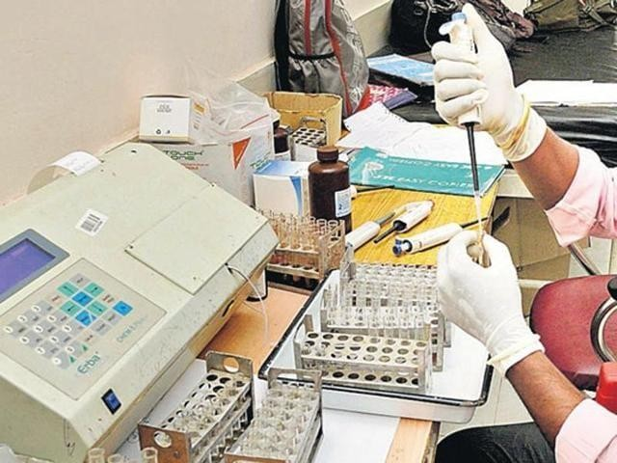
Figure no.8-PATHOLOGY

Routine Testes done in Pathology
Blood Tests: It is the most common pathological test which a doctor prescribes to detect
any abnormalities or illness. Your doctor might also recommend you to do blood test annually to monitor your health.
Some common blood tests are as follows-
  - CBC
  - Erythrocyte Sedimentation Rate (ESR) Test

  - Blood Grouping
  - Basic Metabolic Panel
  - Lipid Profile
  - Thyroid Panel
  - Blood Glucose Test
  - Calcium Blood Test

OBSERVATION

The hospital is a place where patients come with their physical and mental problems. here they provided with different medical facilities. There are different department in hospital. each department has its own value. the nursing staff and physicians are mainly involved in the diagnosis and treatment in the patients. They provide complete care to the patients. The patient also gets provided with the diet facility. There is proper cleanliness environment if not that may lead to spread the infection. The medication provided to the patients with proper dosage regimen. The injectable provided with a very careful manner. To observe patient’s condition the nursing staff present there all the time the behavior of the doctors and nursing staff are friendly and good nurtured.
After 45 days Hospital training I learn about dealing with hospital conditions like diseases of the patients, wards, staff members, different departments, etc.

RESULT AND CONCLUSION

The hospital is a place that provide a primary health care to the patient. To better serve the wide-ranging needs of the community, the modern hospital has often developed outpatient facilities, as well as emergency, psychiatric, and rehabilitation services. The hospital management is maintained by different departments such as outpatient department, surgical departments, nursing department. This also provide emergency services, radiology services, laboratory services, ambulatory services. The hospital usually improves patient’s healthcare and provide primary health care. The main aim of the hospital services is to preserve life, prevent injury, relieve pain, promote recovery and provide protection. They also help to manage life threatening emergency situations. the physicians collect complete information of the patients to understand patients need and correct treatment. The dispensary helps us to understand the dosage regimen of the drug and helps us to understand the prescription details.

CONCLUSION

The experience during the training of 45 days in RAM SAGAR MISHRA 100 BEDDED COMBINED HOSPITAL very productive and fertile. This training helps me to enhance my knowledge and give the basic idea of hospital management. It helps me acquire knowledge about the medicine, information about diagnostic report. It also helps me to examine patient for various diseases.
Here I got practical knowledge about artificial respiration and wound dressing, sites of injection which includes knowledge of syringes, route of injection such as iv, im, ip, etc.
In prescription reading, its parts and the abbreviations used were studied.
Here I also learned about the medical specialty that confirms the cause and nature of the various disease by testing and examining body tissues and fluids. Due to this we are now able to access any patient’s medical report and identify the patient’s health condition.
During training of 45 days, I got an enough time to acquire knowledge about hospital and its features.

BIBLIOGRAPHY

- https://en.wikipedia.org/wiki/Hospital
- https://www.linkedin.com/pulse/importance-ambulance-services-society-ziqitza-healthcare- ltd- -
:~:text=Ambulance%20services%20provide%20prompt%20medical,prevent%20the%20cond ition%20from%20worsening.
- https://www.verywellhealth.com/basic-first-aid-procedures-1298578
- https://en.wikipedia.org/wiki/Outpatient_department -
:~:text=An%20outpatient%20department%20or%20outpatient,be%20admitted%20for%20ov ernight%20care.
- https://www.maxhealthcare.in/blogs/understanding-role-of-emergency-department
- https://en.wikipedia.org/wiki/Childbirth
- https://www.bccnm.ca/RN/learning/medication/Pages/dispensing.aspx
- https://www.verywellfamily.com/labor-delivery-recovery-and-postpartum-room-2759073 -
:~:text=The%20labor%20room%20is%20one,centers%20use%20for%20their%20care.
- https://www.rcpath.org/discover-pathology/what-is-pathology.html -
:~:text=Pathology%20is%
- https://www.rcpa.edu.au/Pathology-Careers/What-is-Pathology

